FUN PROJECT REPORT

Dice Simulator

Submitted by:

Shanet P Roy

1. Introduction
The Dice Simulator is a simple Python program developed to demonstrate fundamental programming concepts such as random number generation, user input handling, and console-based interaction. The project replicates the action of rolling a six-sided dice by producing a random number between 1 and 6. Although small in scope, this project serves as an introductory simulation exercise suitable for beginners learning Python programming.

2. Problem Statement
The objective of this project is to simulate the roll of a standard dice using Python. Every execution of the program should generate a random output within the range of 1 to 6. An optional enhancement allows the user to roll the dice multiple times.

3. Objectives
The key objectives of this project include:
1. To implement a basic simulation using Python.
2. To apply the random module for generating random outcomes.
3. To design a simple program that interacts with the user.
4. To understand basic control flow and program structure.

4. Methodology
The methodology consists of the following major steps:

4.1 Import Necessary Libraries
The program imports the random library, which is used to generate random integers.

4.2 Implement Dice Roll Logic
The core logic uses the function:
random.randint(1, 6)
This ensures each number has an equal probability of appearing.

4.3 Display the Result
The program prints the result to the console, showing the number rolled.

4.4 Optional User Interaction Loop
An additional loop allows the user to roll the dice multiple times if they choose to continue.

5. Code Implementation
The following Python code was used to create the Dice Simulator:

import random

print("Welcome to the Dice Simulator!")

while True:
input("Press Enter to roll the dice...")
print("You rolled:", random.randint(1, 6))

again = input("Roll again? (y/n): ")
if again.lower() != "y":
print("Thank you for using the Dice Simulator!")
break

6. Results
The program successfully generates random dice rolls each time it is executed.
Example output:
Press Enter to roll the dice...
You rolled: 4
Roll again? (y/n): y
Press Enter to roll the dice...
You rolled: 1
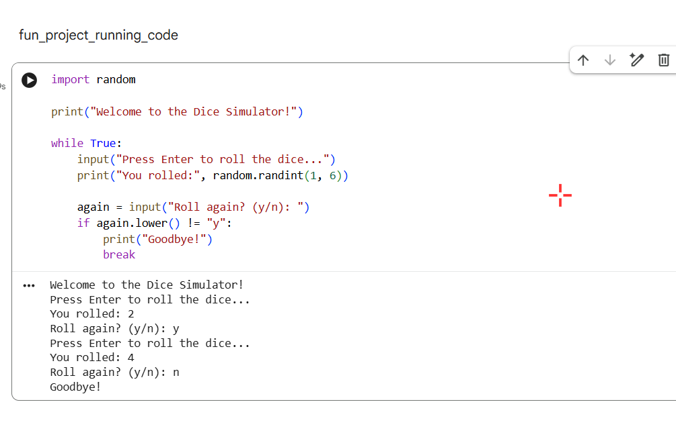

7. Tools and Technologies Used
- Programming Language: Python
- Library: random
- Platform Used: Google Colab
- Environment Type: Interactive Notebook

8. Conclusion
The Dice Simulator project effectively demonstrates the use of Python for creating a simple simulation. The program is concise, user-friendly, and fully functional. It provides a strong foundation for understanding random number generation, input handling, and basic control flow structures. This project can be easily expanded into more complex simulations or games, making it valuable for further learning and experimentation.

9. References
- Python Documentation: https://docs.python.org
- Google Colab Platform

